**AUTH GUARD AND LOGIN GUARD SERVICE ANGULAR 4**

REF:

<https://codecraft.tv/courses/angular/routing/router-guards/>

<http://jasonwatmore.com/post/2016/12/08/angular-2-redirect-to-previous-url-after-login-with-auth-guard>

IN ORDER TO REACH THIS, WE HAVE TO CONFIGURE SOME CODE IN FRONTEND APP:

1. CREATE NEW SERVICE WHICH IMPLEMENTS ***@ Injectable()***. THIS IS OUR ***auth-guard.service.ts***
2. IMPORT ***CanActivate*** AND ***Router*** MODULES FROM ***@angular/router***
3. IMPORT ***LoginService*** TO DETERMINE IF USER IS ALREADY LOGGED OR NOT
4. IMPLEMENTS ***CanActivate*** INTERFACE
5. OVERRIDE ***canActivate*** METHOD TO PREVENT UNLOGGED USERS REACH AUTHORIZATION BASED ROUTES. IF USER IS NOT LOGGED HE WILL BE REDIRECT TO ***/login*** INTERFACE

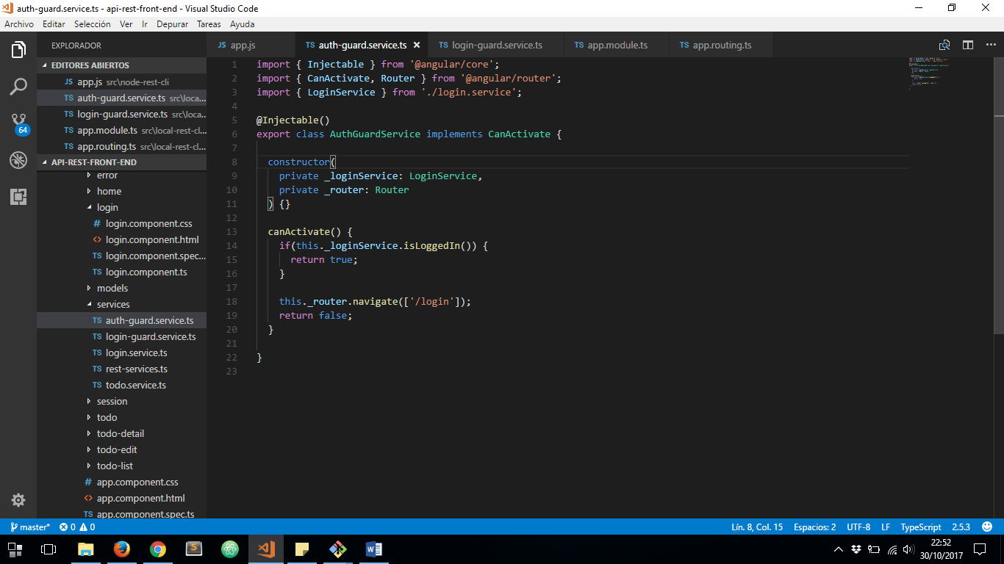

NOW WE HAVE TO CREATE ANOTHER SERVICE WHICH WILL PREVENT LOGGED USER TO REACH ***/login*** ROUTE AGAIN, BECAUSE THAT IS UNNECESSARY.

1. CREATE NEW SERVICE WHICH IMPLEMENTS ***@ Injectable()***. THIS IS OUR ***login-guard.service.ts***
2. IMPORT ***CanActivate*** AND ***Router*** MODULES FROM ***@angular/router***
3. IMPORT ***LoginService*** TO DETERMINE IF USER IS ALREADY LOGGED OR NOT
4. IMPLEMENTS ***CanActivate*** INTERFACE

OVERRIDE ***canActivate*** METHOD TO PREVENT LOGGED USERS REACH ***/login*** ROUTE. IF USER IS ALREADY LOGGED HE WILL BE REDIRECT TO ***/home*** INTERFACE

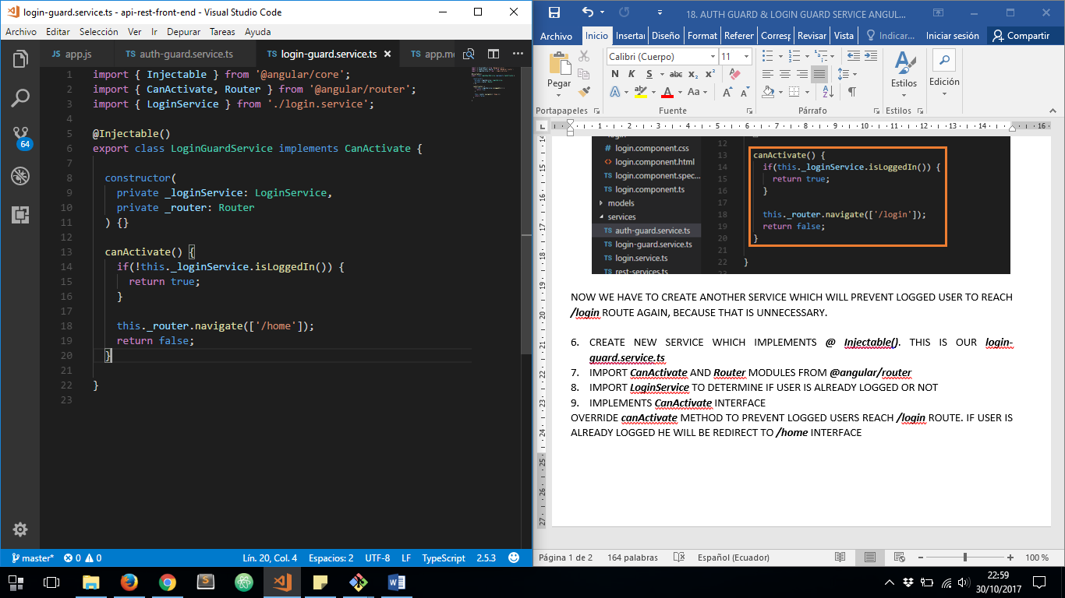

NOW WE MUST DEFINE BOTH SERVICES AS PROVIDERS ON ***app.module.ts***

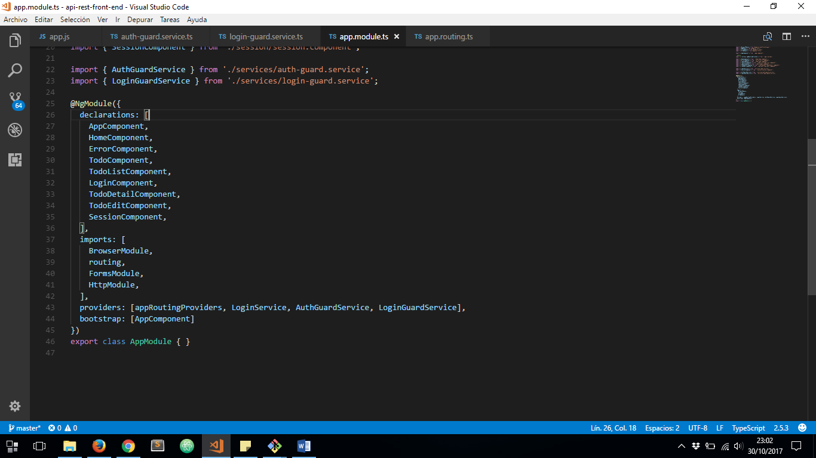

FINALLY, ON ***app.routing.ts*** FILE WE HAVE TO CALL BOTH SERVICES TO PREVENT UNAUTHORIZED ACCESS TO EACH ROUTE:

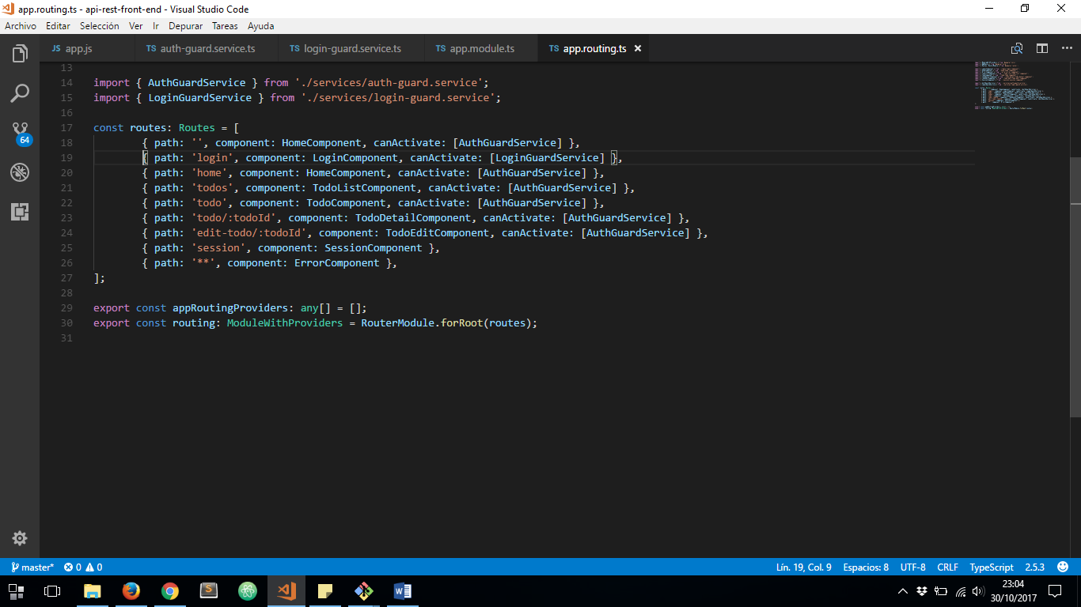

AND THAT’S ALL